

[NEWS LINK](https://epaper.observerbd.com/index.php?cd=2024/09/25/)

MD. IMRAN MUNSHI, ROLL: 01-017-03

We stand for people’s rights

the

Dailyobserver

Dhaka | September 25,2024|Ashwin10,1431 BS | Rabiul Awal 21,1446 Hijri |WEDNESDAY | Vol13|No.256| Regd.No. DA6132|16page|Price Tk 10

UN CHIEF WARNS LEBANON ON ‘BRINK’

AS WORLD LEADERS GATHER IN UNGA

PAGE 8

POPE ASKE FOR SUU KYI’S RELEASE,

PFFERS HER REFUGE ON VATICAN

PAGE 9

BD SEEKS IMF’S

TECHNICAL SUPPORT

FOR BANKING

REFORMS

PAGE 13

**Biden extends full support to BD, Dr Yunus-led interim govt**

**Interview With Reuters**

**Army chief pledges support for interim govt, hopes for polls in 18 months**

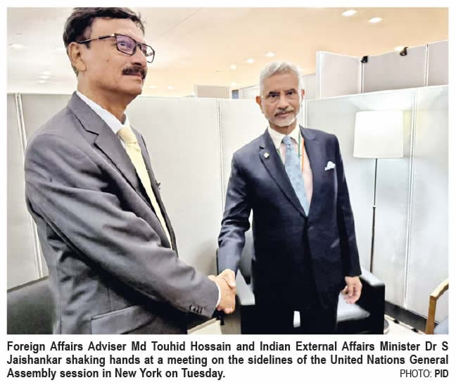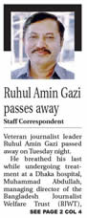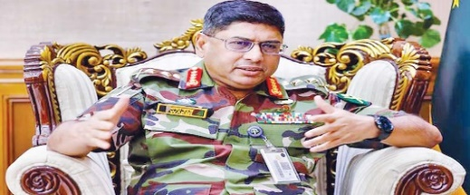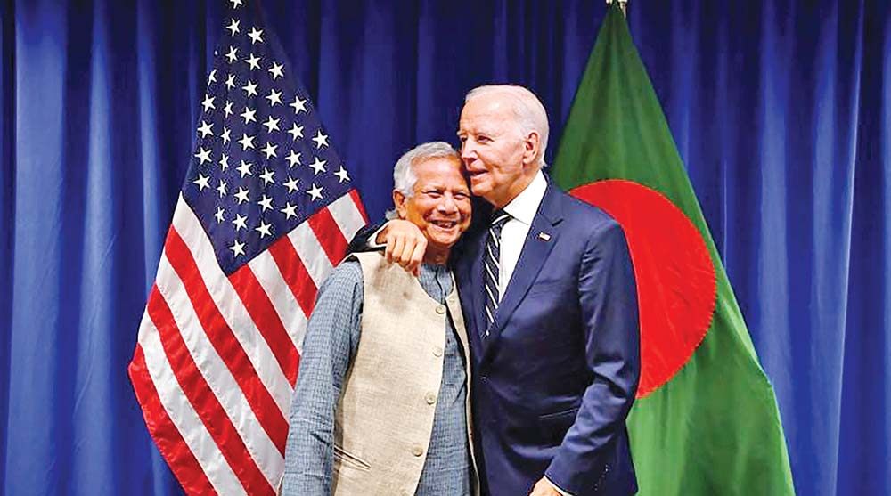

NEWS LINK: <https://epaper.observerbd.com/index.php?cd=2024/09/25/#>

Some 102 leaders and activists of BNP, including its Standing Committee Member Gayeshwar Chandra Roy and Senior Joint Secretary General Ruhul Kabir Rizvi Ahmed were discharged by a Dhaka court on Tuesday from a case filed under the Special Powers Act.

**Gayeshwar, Rizvi, 100 others discharged from SPA case**

**Ministry submit July dead list**

NEW YORK, Sept 24: Canadian Prime Minister Justin Trudeau has appreciated Chief Adviser Prof Muhammad Yunus for assuming the responsibility and expressed Canada's readiness to support institution building in Bangladesh.  
Bangladesh Chief Adviser Prof Dr Muhammad Yunus  **See page 2 col 1**

**Shakib among 7 fined for share price manipilation**

NEW YORK, Sept 24: Canadian Prime Minister Justin Trudeau has appreciated Chief Adviser Prof Muhammad Yunus for assuming the responsibility and expressed Canada's readiness to support institution building in Bangladesh.  
BangladeshChief Adviser Prof Dr Muhammad Yunus  **See page 2 col 1**

(UNGA) in New York on Monday, according to a message disseminated by the Ministry of Foreign Affairs here today. At the summit, Hossain emphasized the importance of a shared global vision built on the "Pact for Future" principles, introduced by UN Secretary-General Guterres. The foreign adviser lauded the Summit, which brought together  **see page 2 col 5**

Bangladesh has expressed its commitment for contributing to the global agenda beyond 2030, focusing on equitable development, empathy and sustainability.  
  
Foreign Adviser Md Touhid Hossain made the commitment when he was addressing the high-level event, the 'Summit for Future' on sideline of the 79th United Nations General Assembly

**BD pledges support for Post-Agenda 2030 visions at 'Summit for Future'**

"Had a meeting with Foreign Affairs Adviser Md Touhid Hossain of Bangladesh in New York this evening. The conversation focussed on our bilateral ties," Jaishankar said on the same platform.  
Bangladesh and India have discussed issues of mutual interest, according to the

**SEE PAGE 2 COL 5**

Foreign Affairs Adviser Md Touhid Hossain and Indian External Affairs Minister Dr S Jaishankar met on the sidelines of the United Nations General Assembly in New York on Tuesday noon.  
  
"Two sides had discussed issues of mutual interest concerning the two countries," Bangladesh's Ministry of Foreign Affairs said on X, formerly Twitter, following the meeting.   
The meeting takes

**Trudeau supports Dr Yunus for institution building in BD**

NEW YORK, Sept 24: Canadian Prime Minister Justin Trudeau has appreciated Chief Adviser Prof Muhamma  
Bangladesh Chief Adviser Prof NEW YORK, Sept 24: Canadian Dr Muhammad Yunus  **See page 2 col 1**

**Towhid-Jaishankar met in UN, agrees to consolidate BD-India ties**

*Special Correspondent*

*from headquarters, New York*

Judge Mohammad Ibrahim Miah of First Additional Metropolitan Sessions Judge court passed the order after hearing on the discharge petitions submitted by the accused.  
The other prominent leaders who got free from the case are BNP Joint Secretary General Habibun Nabi Khan Sohel, Saiful Alam Nirob, **SEE PAGE 2 COL 4**

# gVeteran journalist leader Ruhul Amin Gazi passed away on Tuesday night. **Ruhul Amin Gazi passes away**

Staff correspondent

He breathed his last while undergoing treatment at a Dhaka hospital, Muhammad Abdullah, managing director of the Bangladesh Journalist Welfare Trust (BJWT)**, SEE PAGE 3 COL 4**

**BD pays $150m of $800m dues owed to Adani Power**

Bangladesh's interim government paid about $150 million out of $800 million in dues for power supplied by Adani Power Ltd.'s coal-fired plant in the Godda district of the eastern Indian state of Jharkhand, as per a Bloomberg report.  
  
Bangladesh's interim government started clearing unpaid dues to Adani Power for electricity, said central bank Governor Ahsan H. Mansur. Bangladesh's overall arrears amounted to $2.5 billion as of August with the energy sector accounting for the "bulk of the amount" according to Bloomberg.  
  
Adani Power's 1,600 mega watt plant in Godda, Jharkhand has a contract with the Bangladesh Power Development Board to supply its entire output. The average monthly billing for this supply is between $90 and $100 million. The plant generated electricity in June 2023 and has been providing power to Bangladesh

**SEE PAGE 2 COL 4**

(UNGA) in New York on Monday, according to a message disseminated by the Ministry of Foreign Affairs here today. At the summit, Hossain emphasized the importance of a shared global vision built on the "Pact for Future" principles, introduced by UN Secretary-General Guterres. The foreign adviser lauded the Summit, which brought together  **see page 2 col 5**

Foreign Affairs Adviser Md Touhid Hossain and Indian External Affairs Minister Dr S Jaishankar met on the sidelines of the United Nations General Assembly in New York on Tuesday noon.  
"Two sides had discussed issues of mutual interest concerning the two countries," Bangladesh's Ministry of Foreign Affairs said on X, formerly Twitter, following the meeting.   
The meeting takes

**Govt mulls stopping handing over Ctg Port to foreign operators**

*Special Correspondent*

*from headquarters, New York*



**Lt Tanjim stabbed to death by robbers in Chakaria**

[***Staff Correspondent***](https://www.observerbd.com/author/Staff-Correspondent)

An army officer was stabbed to death during an operation of joint forces in Dulahazara area of Chakaria upazila under Cox's Bazar district

The deceased Lt Tanjim

**SEEE PAGE 2 COL 1**

**CA joins UN Secretary General's reception**

NEW YORK, Sept 24: Chief Adviser Professor Muhammad Yunus today joined a welcome reception hosted by United Nations (UN) Secretary General Antonio Guterres.  
  
The reception ceremony began at 8 am (NY time) at North Delegate Lounge of the UN headquarters in New York to welcome the global leaders joining the 79th session of the United Nations

**SEE PAGE 2 COL4**At the reception, Prof Yunus exchanged pleasantries with Brazil

**Trudeau supports Dr Yunus for institution building in BD**

NEW YORK, Sept 24: Canadian Prime Minister Justin Trudeau has appreciated Chief Adviser Prof Muhammad Yunus for assuming the responsibility and expressed Canada's readiness to support institution building in Bangladesh.  
Bangladesh Chief Adviser Prof Dr Muhammad Yunus  **See page 2 col 1**

HIGHLIGHT

* Army stood alongside students in July August protest, s4ealing the fate of former prime minister Shikh Hasina
* Interim government led by Yunus has his full support
* ‘Democracy transition and election should be within 18 months.
* Bangladesh Army will not intervene in politics
* Military must not be used for political purpose ever

Us president warmly hugs Chief Adviser Dr Muhammad Yunus

NEW YORK, Sept 24: US President Joe Biden has expressed his government's "full support" to Bangladesh and Prof Dr Muhammad Yunus-led Interim Government of Bangladesh during his rare one-to-one bilateral meeting with the Bangladesh Chief Adviser on the sidelines of the UN General Assembly in New York.  
  
Chief Adviser Prof Dr Yunus held the meeting with the US President on Tuesday morning (NY Time) which is seen as a "rare occasion" and will help take the existing good relations to a new level between the two countries.  
  
During the meeting, Prof Dr Yunus apprised him about how the students rose against the tyranny of the previous government and gave their lives to create this opportunity to rebuild Bangladesh.

Prof Dr Yunus stressed that his government must succeed in rebuilding the country and would need US cooperation.

**SEE PAGE 2 COL 5**

Bangladesh Army Chief General Waker-uz-Zaman vowed to back the country's interim government "come what may" to help it complete key reforms after the ouster of prime minister Sheikh Hasina, so that elections could be held within the next 18 months.  
General Waker-uz-Zaman and his troops stood aside in July and early August amid raging student-led protests against Hasina, sealing the fate of the veteran politician who resigned after 15 years in power and fled to neighbouring India.

In a rare media interview, Zaman told Reuters at his office in the capital Dhaka on Monday that the interim administration led by Chief Adviser Muhammad Yunus had his full support and outlined a pathway to rid the military of political influence.  
"I will stand beside him [chief adviser]. Come what may. So that he can accomplish his mission," Zaman, bespectacled and dressed in military fatigues, said of Yunus.  
The pioneer of the global microcredit movement, Yunus has promised to carry out essential reforms to the

**See page 2 col 5**

**Us president Joe Biden warmly hugs Chief Adviser Nobel Laureate Dr Muhammad Yunus**

NEW YORK, Sept 24: US President Joe Biden has expressed his government's "full support" to Bangladesh and Prof Dr Muhammad Yunus-led Interim Government of Bangladesh during his rare one-to-one bilateral meeting with the Bangladesh Chief Adviser on the sidelines of the UN General Assembly in New York.  
  
Chief Adviser Prof Dr Yunus held the meeting with the US President on Tuesday morning (NY Time) which is seen as a "rare occasion" and will help take the existing good relations to a new level between the two countries.  
  
During the meeting, Prof Dr Yunus apprised him about how the students rose against the tyranny of the previous government and gave their lives to create this opportunity to rebuild Bangladesh.

**See page 2 col 3**